SAP Mobility 101

Tutorial 10 – Filters

This tutorial relates to an approach to mobile web application development. Creating a mobile application that is web based ensures that the application can open through multiple web browsers on any smartphone. The first part of the tutorial is to explore HTML and CSS.

# Objective of Exercise

## Build an example application

The objective of this exercise is to build an HTML page that uses JavaScript and output values in a table.

## Note

* We recommend that you use a chrome browser for testing
* Eclipse Juno would be needed for this Tutorial.

# Task 1: Add a filter to the table

In the API reference of bindItems, there are a property that can be set: filters.

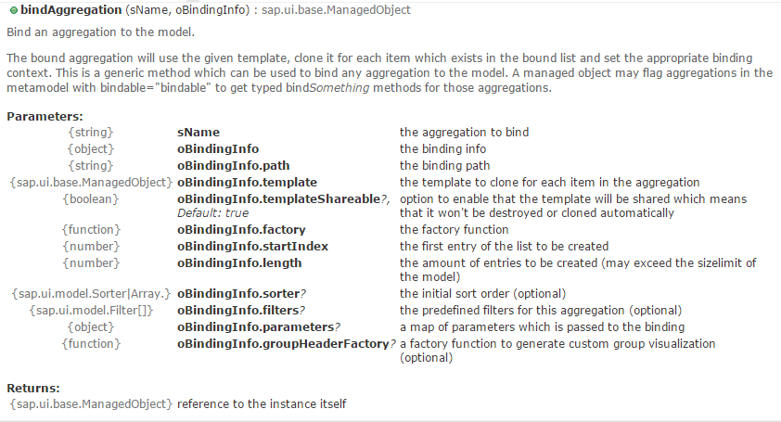Add a filter named oFilter to the Products table on the second view:

list.bindAggregation("items", {

path: "data2>/Products",

filters: oFilters,

# template: otemplate});

# Task 2: Create the filter

Under the API reference for filter, there are different methods of creating a new filter:

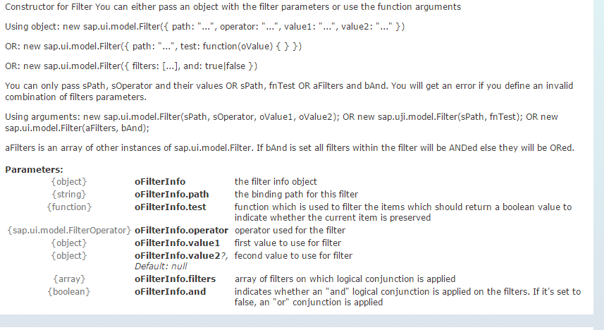

Create a filter that only lets the CategoryID 2 through:

**var** oFilters = [

**new** sap.ui.model.Filter(

"CategoryID", "EQ", "2"

)];

Result:



 